**Steps to Run Application: (Only for .docx file support)**

1. Install Anaconda if not installed

2. Open Anaconda prompt

**Install Module:**

1. django => pip install django

2. nltk => pip install nltk

3. docx2txt => pip install docx2txt

4. shutil => pip install shutil

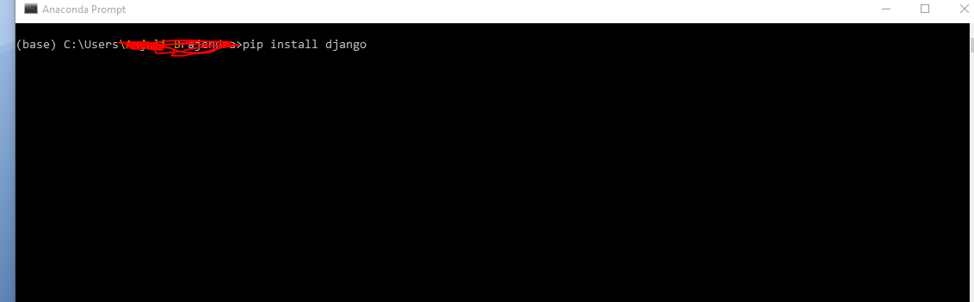

* Configuration for directories location in CvApp/view.py :-

Change these highlighted paths as per your location

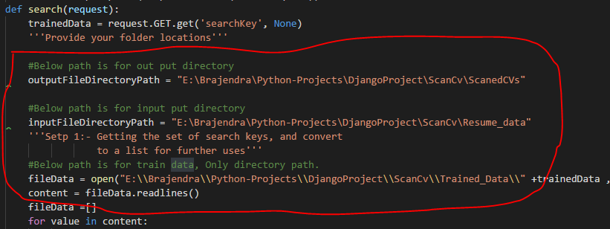

Path1: Below path is used for saving the scanned resume

#Below path is for out put directory

outputFileDirectoryPath = "E:\Brajendra\Python-Projects\DjangoProject\ScanCv\ScanedCVs"

Path 2: Below path is used for getting the resumes for scan . (Input resumes )

#Below path is for input put directory

inputFileDirectoryPath = "E:\Brajendra\Python-Projects\DjangoProject\ScanCv\Resume_data"

Path 3 : Below path is used for trained data.

#Below path is for train data, Only directory path.

fileData = open("E:\\Brajendra\\Python-Projects\\DjangoProject\\ScanCv\\Trained_Data\\" +trainedData ,'r')

* Steps for running the Application:

Open Anaconda prompt and run the application by using below command –

>python manage.py runserver

Press **Enter** button

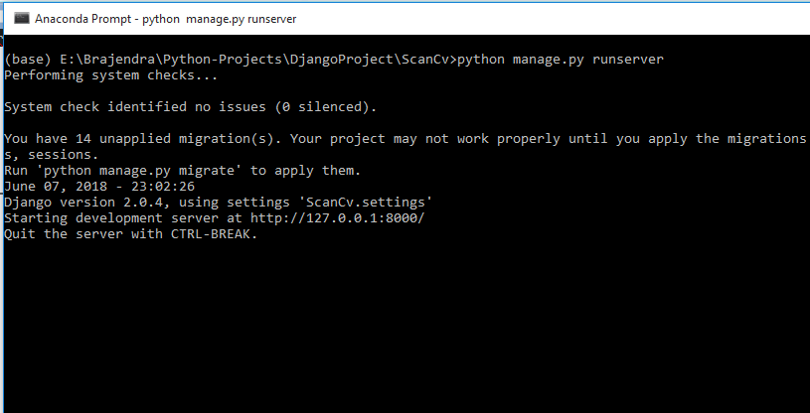

* Now open browser with URL : <http://127.0.0.1:8000/scancv>

You will get below screen

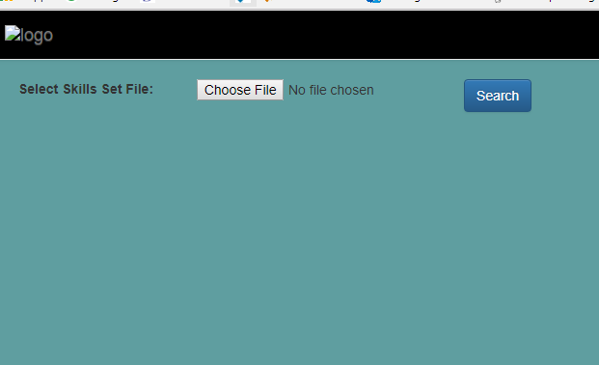

Now browse trained data file and click Search button.

